MAYOR BYRON W. BROWN’s
7th GUN BUYBACK PROGRAM
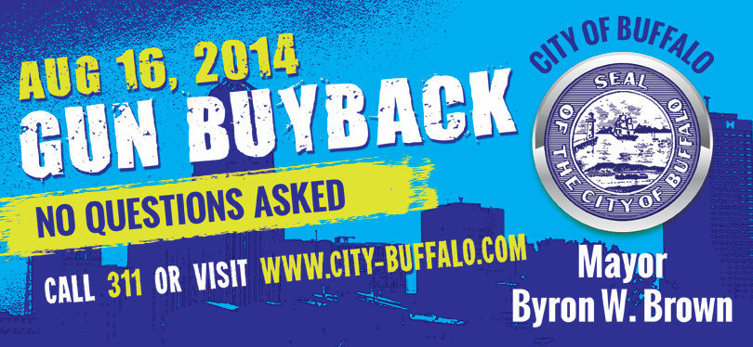
Mayor Brown’s Gun BuyBack program is a safe, no questions asked way to remove all guns from your home.
AUGUST 16, 2014
You’ll get a pre-paid credit card for each gun you turn in!
$10.00 Non-working or antique guns
(including BB guns and pellet guns)
$50.00 Rifles/Shotguns
$75.00 Handguns
$100.00 Assault Weapons (e.g., Uzis, AK-47s)
East Side Location: South Buffalo Location:
True Bethel Baptist Church St. Thomas Aquinas Catholic Church
907 East Ferry Street 450 Abbott Road
Downtown Location: West Side Locations:
St. John Baptist Church Primera United Methodist Church
184 Goodell Street 62 Virginia Street
North Buffalo Location:
Church of the Good Shepherd
96 Jewett Parkway
Riverside Location:
St. Mark’s Episcopal Church
213 Ontario Street

PENALTIES FOR ILLEGAL GUNS ARE STIFFER THAN EVER

